Samarth Rural Educational Institute’s
Samarth College of Computer Science, Belhe
Academic Year 2026-2027(SEM-V)
T.Y.B.Sc.(Information Technology)
Practical NO:6
Title : 6.Dynamic Data Display
Roll NO: 70 Batch : C

SET A :
Q1. Create a Flask application to display student details and calculate the total and average marks dynamically.
Ans:
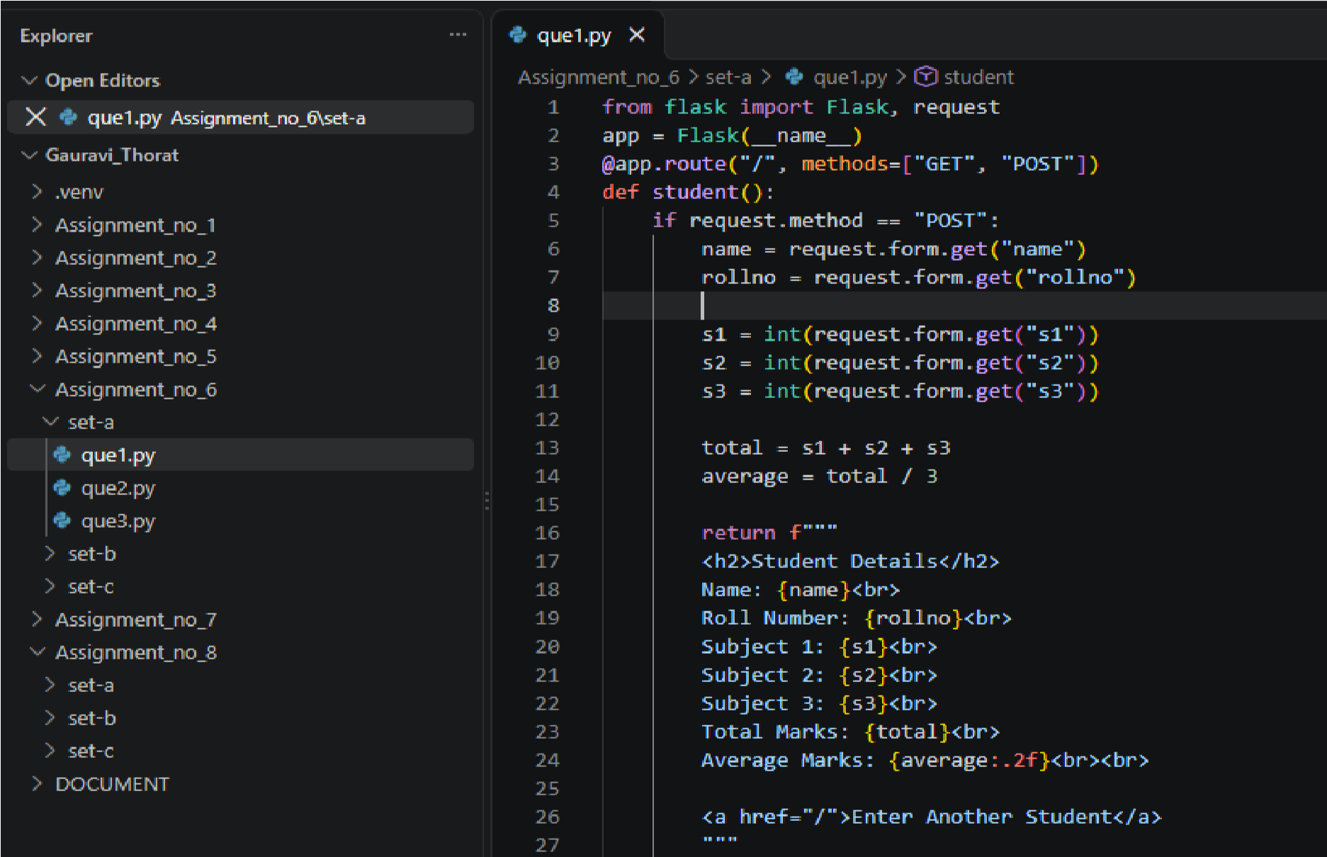
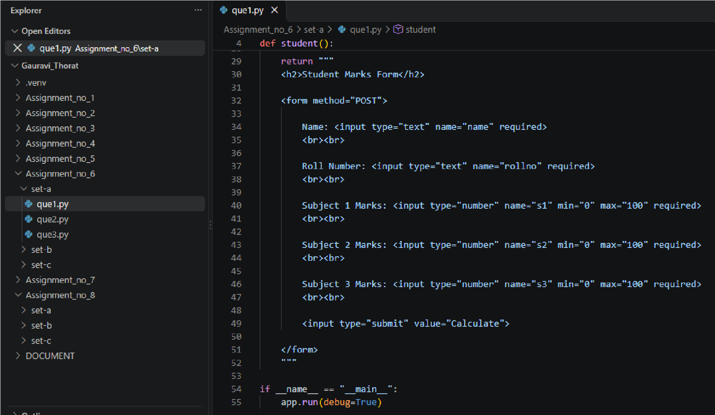
Output:
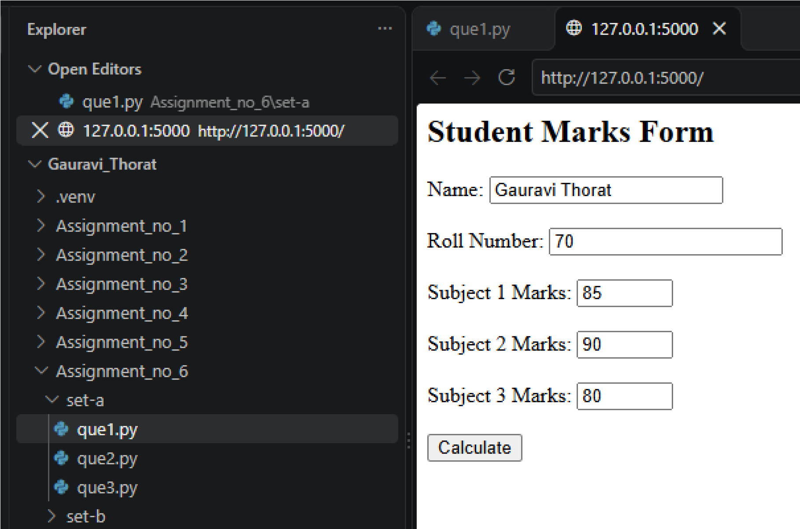
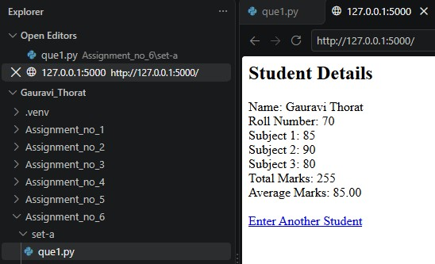

Q2. Create a Flask application to display a list of five student names dynamically.
Ans:
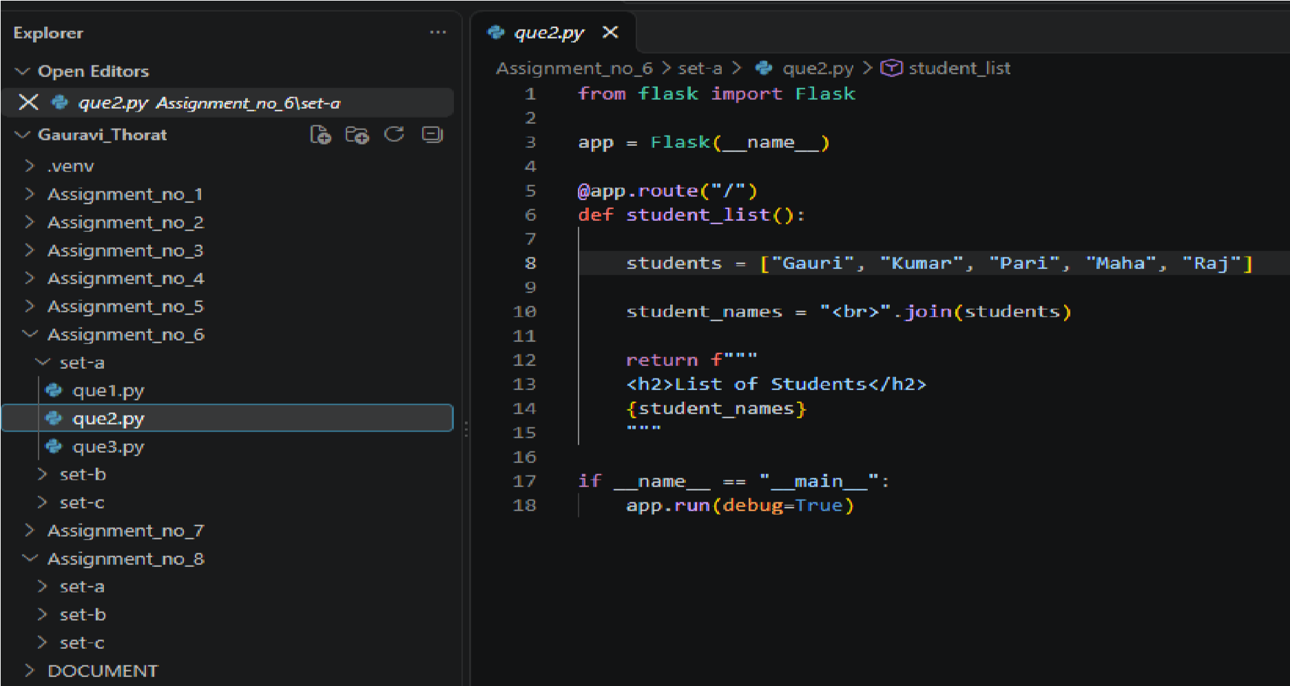

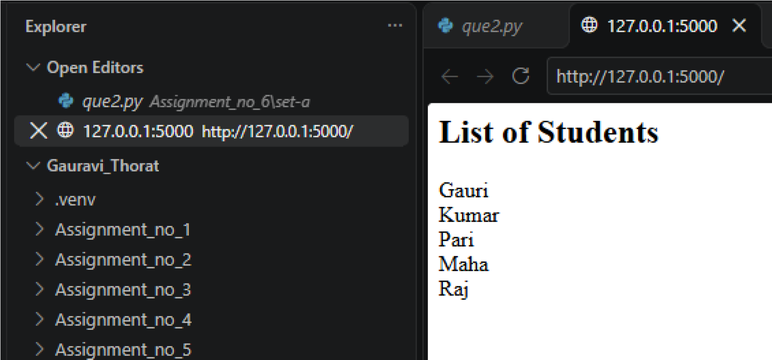
SET B :
Q1. Display student information stored in dictionary.
Ans:
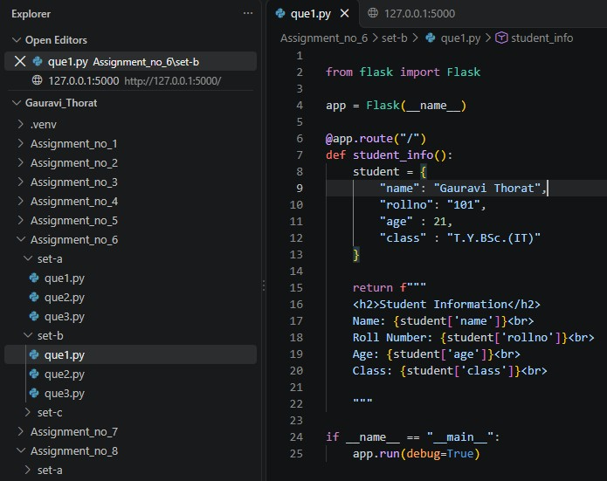
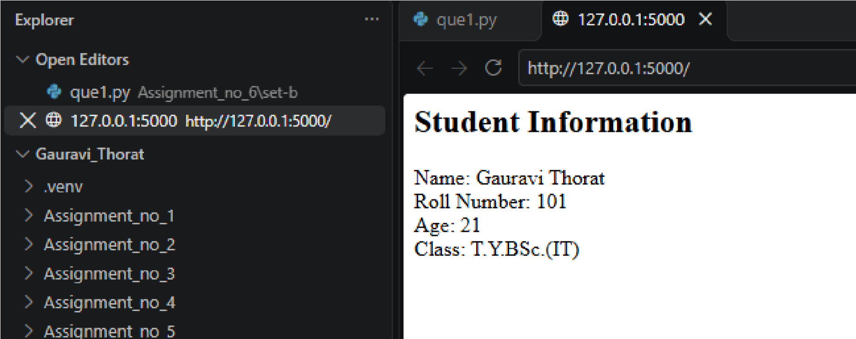

Q2. Create a Flask application to display the details of five employes stored in a Python list.
Ans:
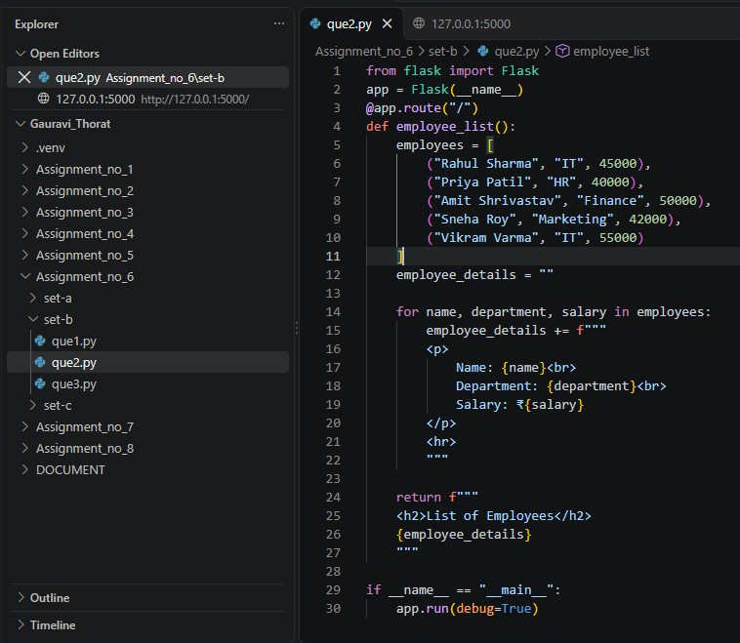
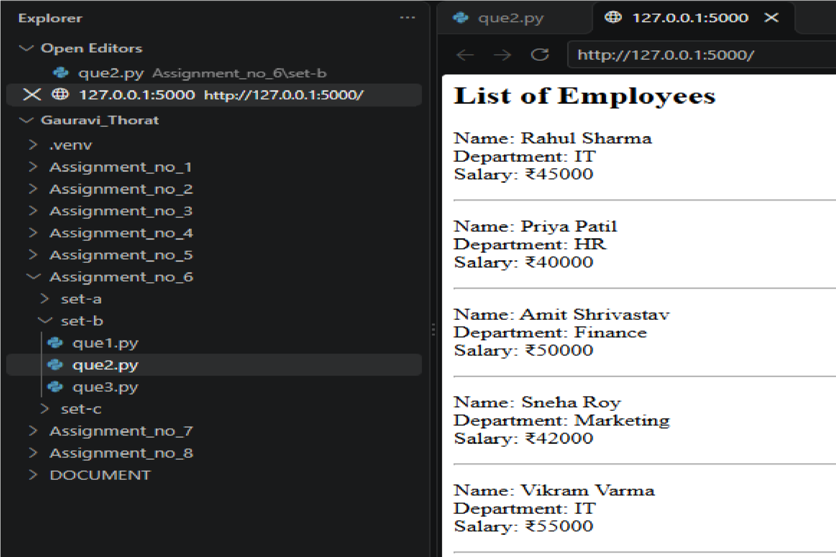

SET C :
Q1. Display employee details stored in a Python list.
Ans:
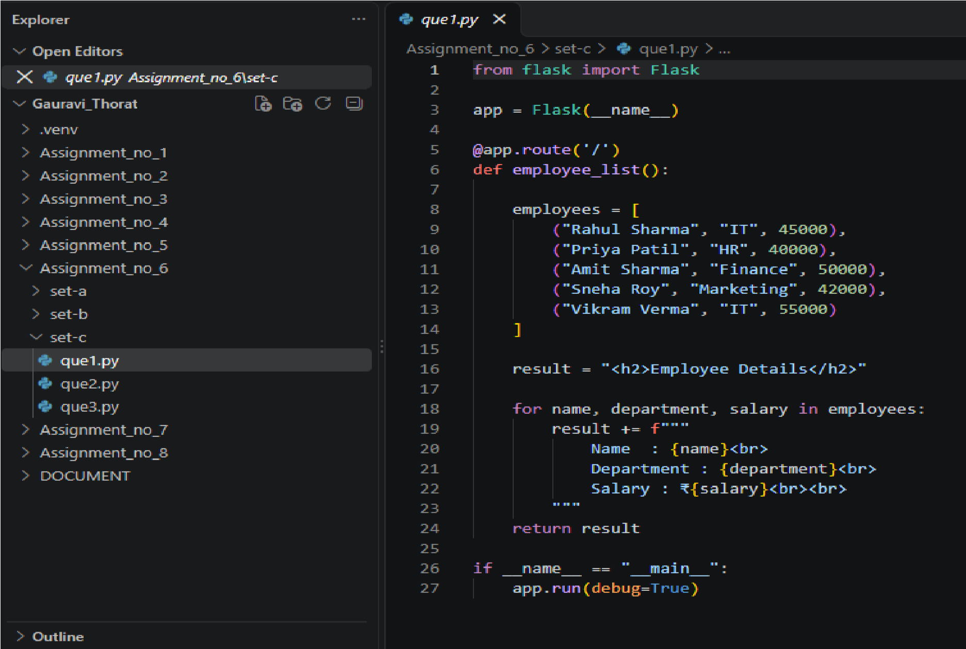

Output:
